Type the title of your proceedings TPH 2020 here
List the author names here (for example A J Smith)
Type the author addresses here
Type the corresponding author’s e-mail address here
Abstract. Start your abstract here…
- The first section in your paper
The first paragraph after a heading is not indented (Bodytext style).
Other paragraphs are indented (BodytextIndented style).
- Another section of your paper
The first paragraph after a heading is not indented (Bodytext style).
Other paragraphs are indented (BodytextIndented style).
Style for formulas (BodytextRight style):
  - A subsection
Some text.
    - A subsubsection. The paragraph text follows on from the subsubsection heading but should not be in italic.
References
- A reference
This reference has two entries but the second one is not numbered (it uses the ‘Reference (no number)’ style.
- Another reference
- More references
- Aderhold J, Davydov V Yu, Fedler F, Klausing H, Mistele D, Rotter T, Semchinova O, Stemmer J and Graul J 2001 J. Cryst. Growth 222 701

Using the TPH 2020 Word templates
- How to use the template
To create a new document simply store the template in a convenient location and double-click it.
- Applying paragraph styles

The template also contains a number of predefined paragraph styles (see table 1) which can be accessed quickly and conveniently using the toolbar provided. To format a paragraph in a particular style simply click on the appropriate style name in the Styles bar.
To display the “Styles and Formatting” bar in Word 2003, just click on the icon or select the appropriate menu item on the “Format” tab. In Word 2007 and later versions, the bar is called “Styles” and activated by pressing the extension button.

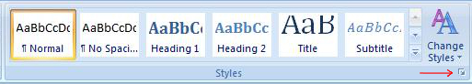
- On/off button of the style bar in MS Office Word.
Key combination “Alt+Ctrl+Shift+S” can be also used.

On the panel (as a rule, on the right) you can see the following style names necessary for article preparation (Figure. 2).
- Sample text
The document created from the template contains some text to help you start formatting your paper, simply delete the text provided and replace it with your own.

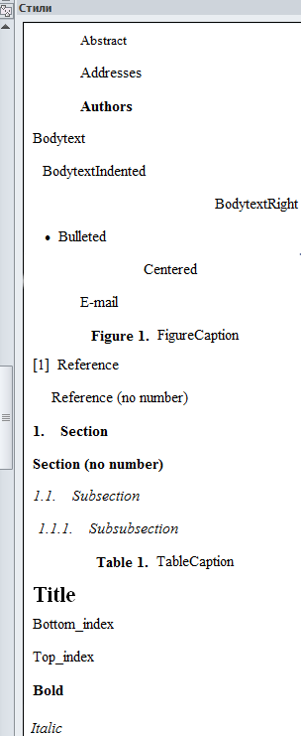
- Styles bar.

- Paragraph styles defined in the template.
Style | Example and use
Title | The title of your paper
Abstract | Style in which to format your Abstract
Addresses | Style for author addresses
Authors | Style for the list of author names
Bodytext | The style for the first paragraph after a section, subsection or subsubsection
BodytextIndented | An indented style for paragraphs that follow after Bodytext
BodytextRight | Style for right-justified text.
Bulleted | - Bulleted list
Centered | Style for figures and centered text.
E-mail | Style for corresponding author’s e-mail address
FigureCaption | - Numbered style for caption of figures
Reference | - The style to use for a numbered reference. Note that when the text reaches the end of the line it will indent slightly
Reference (no number) | A style for references that are part of a numbered reference (where there are multiple entries under a single number)
Section | - Numbered style for section headings
Section (no number) | Style for section headings that are not numbered (e.g., ‘References’)
Subsection | Style for a subsection
Subsubsection | - Style for subsubsection. Type a full stop (‘period’) after the heading text and continue the paragraph in Roman (upright) type
TableCaption | - Numbered style for caption of tables
Bottom_index/Top_index | Bottom and Top indexes
Bold/Italic | Bold and Italic text

